油浸式负荷开关（二工位10kV）
本开关应用于组合式变压器，负荷开关有四位置和二位置开关，四位置开关按结构形式不同可分为丁型、V型和}型。开关安装在组合变压器的箱壁上，以变压器油为绝缘和灭弧介质，适用于频率50日z，设备最高电压12kV, 40.5kV，额定电流315A, 630A三相供电线路，在终端供电或环网供电系统中，作为工业、民用电能的控制和保护装置。在操纵杆的作用下，能使开关在组合式变压器带负荷状态下，作三相联动关、合电源或改变供电方式。

BYFⅠ型油浸式负荷开关
BFY type oil-immersed load break switch
本开关应用于组合式变压器，负荷开关有四位置和二位置开关，四位置开关按结构形式不同可分为丁型、V型和}型。开关安装在组合变压器的箱壁上，以变压器油为绝缘和灭弧介质，适用于频率50日z，设备最高电压12kV, 40.5kV，额定电流315A, 630A三相供电线路，在终端供电或环网供电系统中，作为工业、民用电能的控制和保护装置。在操纵杆的作用下，能使开关在组合式变压器带负荷状态下，作三相联动关、合电源或改变供电方式。
This switch is used for compounded type transformer. It is classified into four-position and two-position products. Thefour-position switch is divided into“T”type、“V”type and“I”.The switch is installed on the tank well of compoundedtransformer, the transformer oil is used for its insulating and are eliminated material. It is suitable for three phase power supply circuit with rated frequency 50Hz, highest voltage for equipment 1 2kV、40.5kV, rated current 315 A and 630A. In the radialfeed or loop feed supply system, it is used as controlling and protective device in the industry civil used electric energy. When functioned by operating pole, the switch can drive three phase linkage cut and close power resource or transfer supply method.

各电压等级的负荷开关，在变压器油中应承受下表规定的试验电压
Voltage class of load switch should withstand the test voltage in transformer oil shown in following table

设备最高电压Highest voltage forequipment(kV) | 额定电压Rated voltage(kV) | 1min工频耐受电压(kV)Power frequency withstand voltage(1min) |  | 雷电冲击耐受电压(kV)Lighting withstand voltage
设备最高电压Highest voltage forequipment(kV) | 额定电压Rated voltage(kV) | 对地、相间To groundOr Interphase | 隔离断口In so lating insulationbetween gaps | 对地、相间To groundOr Interphase | 隔离断口In so lating insulationbetween gaps
12 | 10 | 42 | 48 | 75 | 85
24 | 20 | 55 | 60 | 125 | 145
40.5 | 35 | 95 | 110 | 200 | 215

开关型号、安装尺寸对照表Type of tap change and installation sizechart
开关型号Type of tap-changer | 额定电流(A)Rated current(A) | 最高电压(kV)Highest voltage(kV) | 外形尺寸(mm)Overall dimension(mm)
开关型号Type of tap-changer | 额定电流(A)Rated current(A) | 最高电压(kV)Highest voltage(kV) | H | H1 | H2 | H3 | L | L1
 |  | 40.5 | 558 | 43 | 120 | 181
BYFI -40.5/630-31.5 | 630

BYFI两工位负荷开关外形图
Overall drawing for two-position load break switch

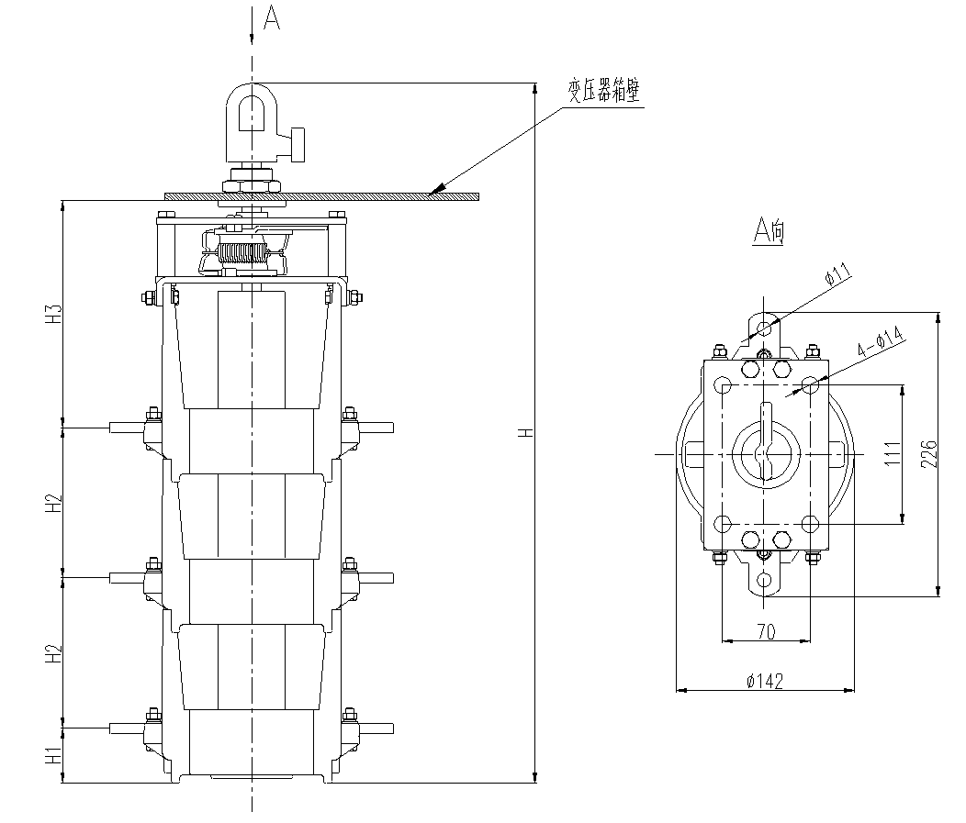

两工位开关箱壁开孔及焊装图
Sketch diagram for making hole on the two-position tank wall and welding

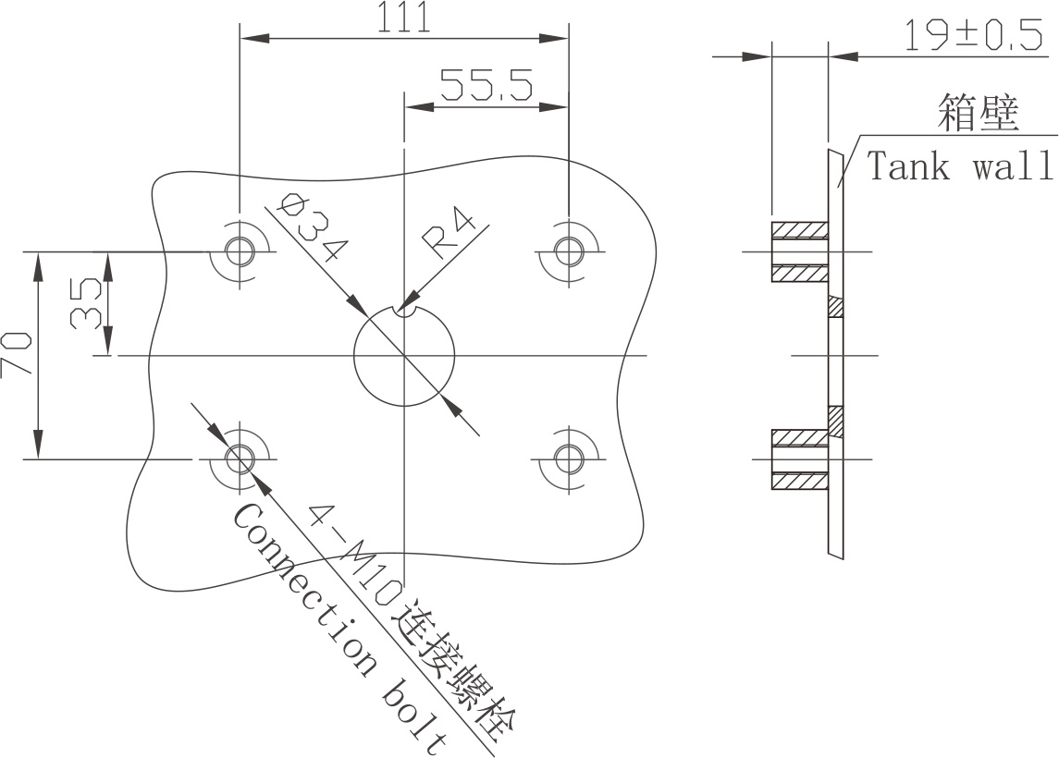

两工位负荷开关带信号安装图及型号
Two-position load switch with signal installation diagram and its type

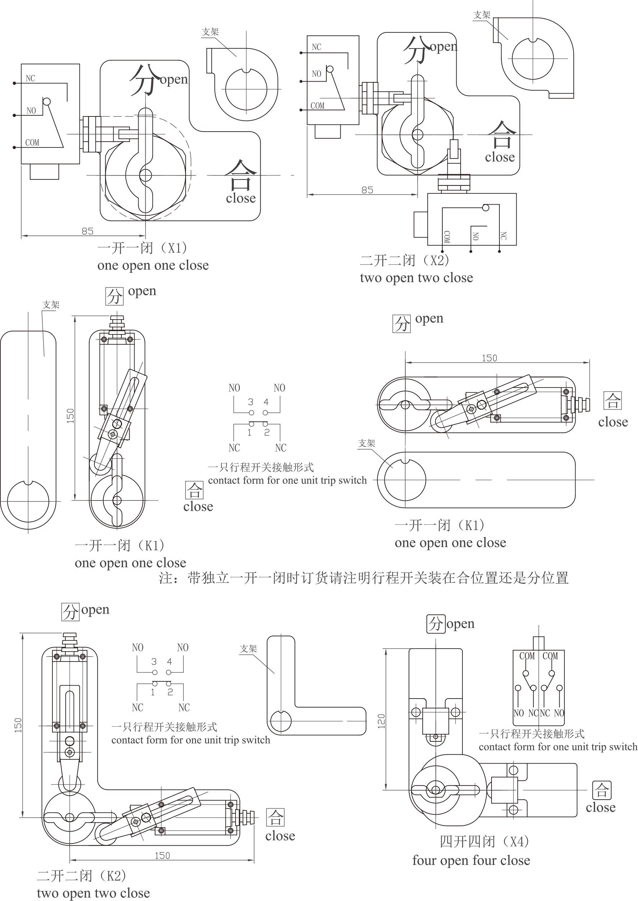
二工位负荷开关带信号接点派生代号说明
Derived code for two position load switch with signal contact

开关型号、安装尺寸对照表Type of tap change and installation sizechart

代号type | 含义Implica ton
X1 | 配置开、闭触点为共用接线的微动开关一只，信号输出为：一开一闭one unit of micro-driven switch with common wiring for open and close contact.signal output type is of one open and one close
X2 | 配置开、闭触点为共用接线的微动开关二只，信号输出为：二开二闭Two unit of micro-driven switches with common wiring for open and close contact，signal output type is of two open and two close
K1 | 配置开、闭触点为独立接线的行程开关一只，信号输出为：一开一闭one unit of trip-driven switch with independent wiring for open and close contact.signal output type is of one open and one close
K2 | 配置开、闭触点为独立接线的行程开关二只，信号输出为：二开二闭two unit of trip-driven switches with independent wring for open and close contact.signal output type is of two open and two close
X4 | 配置开、闭触点为共用接线的行程开关二只，信号输出为：四开四闭two unit of trip-driven switches with common wiring for open and close contact，signal output type is of four open and four close

