WSTII4型无励磁分接开关
该型开关操作机构共有二型，分别如下，未注明情况下开关配置B型

WSTII4系列条型无励磁分接开关
WSTII4 Series linear form de-energized tap-changer
该型开关操作机构共有二型，分别如下，未注明情况下开关配置B型
This type switch operating mechanism has two types,respectively as follows,without indicating ,the switch configuration type is B
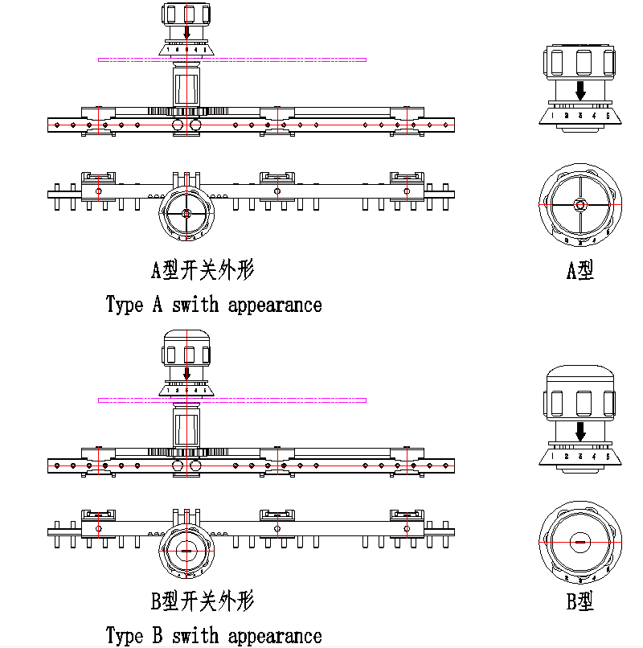

WST II 4T系列条型无励磁分接开关
WST II 4T Series linear form de-energized tap-changer

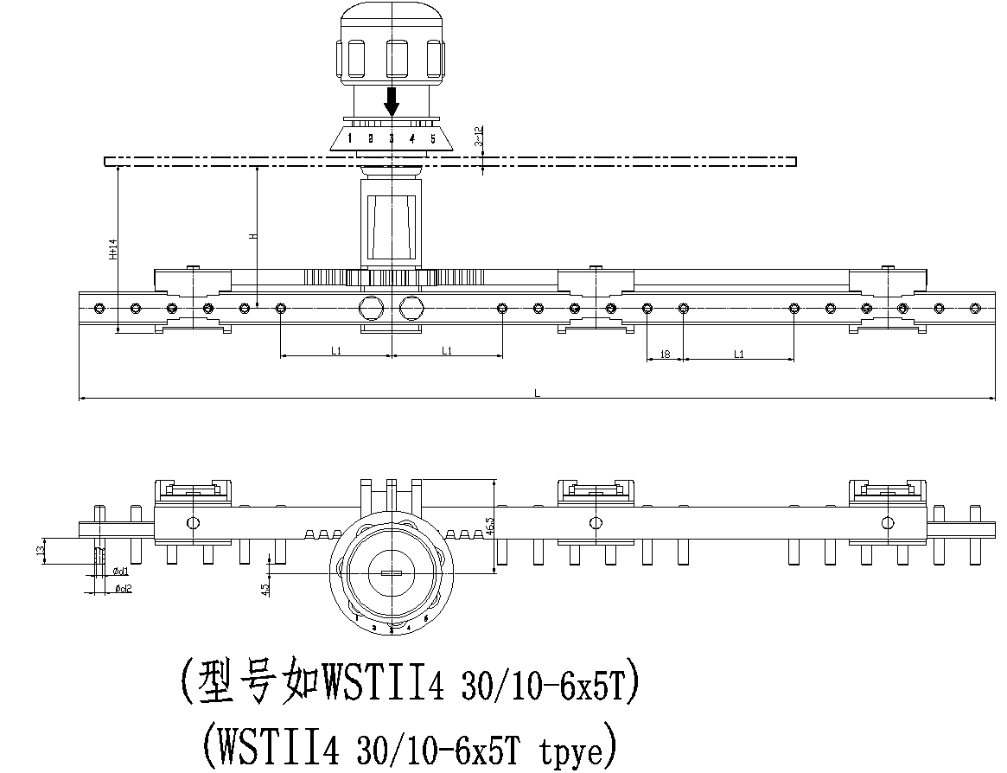
开关型号、安装尺寸对照表Type of tap change and instal tion sizechart
开关型号Type of tap-changer | 安装尺寸Install dimension(mm) |  |  |  |  |  | 箱盖开孔Holes on tank cover(mm)
开关型号Type of tap-changer | H | L | L1 | 1 | od1 | dd2 | 箱盖开孔Holes on tank cover(mm)
WSTⅡ4：30/ 10-4×3T |  | 347 | 55 | 18 | D3.1 | D5 | Φ20
WSTⅡ4：30/10-6×5T |  | 455
WSTⅡ4：30/10-8×7T |  | 563
WSTⅡ4：30/33-6×5T |  | 530
 |  |  |  | 18 | 中5.1 | 中7 | Φ20
WSTⅡ4：63/10-6×5T |  | 455
 |  |  | 80
WSTⅡ4：63/35-6×5T |  | 530
WSTⅡ4：63/40.5-6×5T |  | 530

